SIM Card Connector
User Manual

Model:KF014

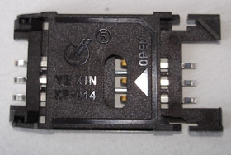

- Characteristics and application
Characteristics:
- Match ISO7816-2；
- Match GSM11.11;
- Compact contact, high accuracy. Au-plating is done by machine automatically with good performance.

Application:
    - Control terminal
    - The intelligence supervises and control the terminal
    - Lead-in data correspondence system
    - Concentrates to copy the form system
    - Telecommunication.
    - The other intelligence identifies the system.

2. Technical property
2.1 General function:
:
Item | Standard | Description
Shape size |  | 30.34L×17W×2.4mm
Weight |  | 1.8g(Approx)
Card dimension | ISO7816-2 | 25.1×15.1×0.76mm
Contact principle |  | Friction technology
Operating position |  | Up/down/horizon
Durability |  | >10000cycles

2.2 Electrical function: subject to IEC512

Name | Standard | Description
2.2.1 Copper flat contact |  | 6pin
Contacts number |  | ≤0.1Ω
contact resistance | IEC512-2-2a | >1000MΩ/500Vdc
insulation resistance | IEC512-2-3a | 5v
Rated voltage |  | 1A max,10μAmin.
Rated current |  | >500V AC a minute of fly without breakdown arc phenomenon

2.3 Mechanical function：

Name | Standard | Description
Contact pressure |  | 0.2N~0.6N
Contact position | ISO 7816-2
Copper flat
Material |  | QSn8-0.3T
Electroplating |  | Ni over Au
Insulating material |  | Thermoplastic plastics

2.4 Soldering：
Name | Standard | Description
Wave |  | No applicable
IR flow |  | 260℃,8-10sec.Max
Manual soldering | IEC68-2-20 | 330℃,3sec.Max

2.5 Environmental characteristic: subject to IEC 68
Name | Standard | Elucidation
Operating temperature |  | -25℃~+85℃
Operating humidity |  | 10%~95%RH
storage temperature |  | -25℃~+85℃
storage humidity |  | 10%~95%RH
Salt spray experiment | IEC68-2-11 | 35℃,5%NaCL,48h

慈溪市烨鑫电子厂
3．Outline size
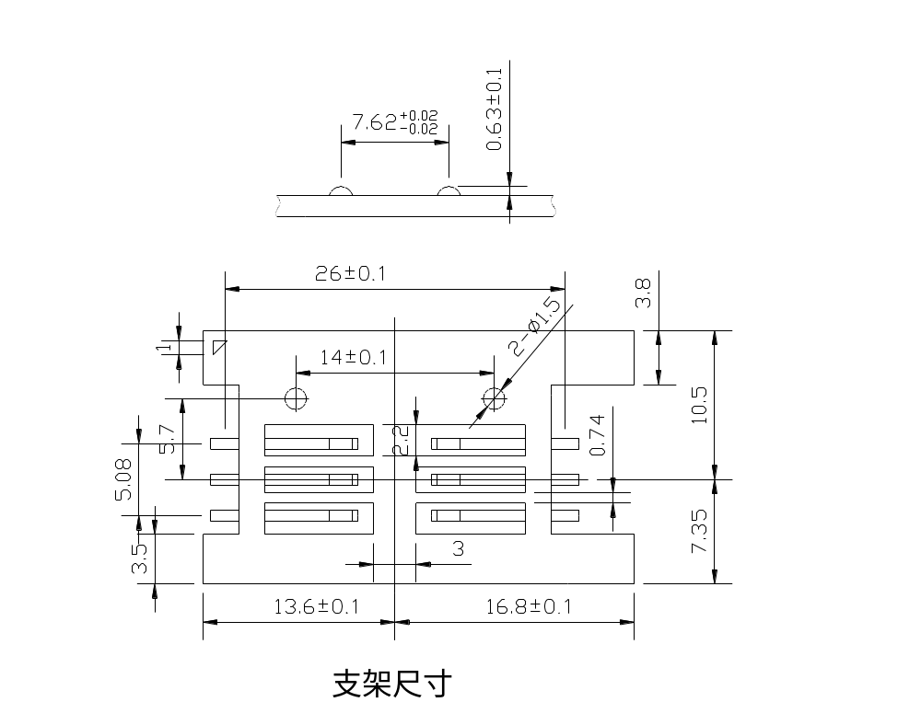

Appendix A：SIM card connector size
